Topology Qualifying Exam, August 2005

Problems
- Let $X=\{(0,y)∣-1≤y≤1\}∪\{(x,sin(1/x))∣0<x≤1\}$. Prove that $X$ is connected but not path connected.
- Prove or give a counterexample: If $q:Y→Z$ is a quotient map and $Y$ is both compact and Hausdorff, then $Z$ must be Hausdorff.
- Prove that the unit interval, $I$, is compact. Be sure to explicitly state any properties of real numbers that you use.
- The identification space $X$, shown below, is called the “dunce hat”. Using Van Kampen’s theorem, compute the fundamental group of $X$.
- 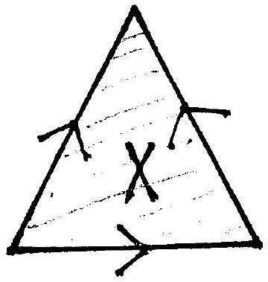
- Compute $H_{0}$ and $H_{1}$ of the complete graph $K_{5}$ formed by taking five points and joining each pair with an edge.
- Let $M_{g}$ be the closed orientable surface of genus $g$. Let $f:M_{g}→M_{g}$ be a continuous map homotopic to the identity. For which $g$ does it follow that $f$ must have a fixed point?
- State the classification theorem for surfaces (compact, without boundary, but not necessarily orientable). For each surface in the classification, indicate the structure of the first homology group and the value of the Euler characteristic. Also, explain briefly how the 2-holed torus and the connected sum $RP^{2}\#RP^{2}$ fit into the classification.

  - Compute the integral homology of $RP^{3}$.
  - Is $RP^{3}$ orientable? How many distinct connected degree $2$ covering spaces does $RP^{3}$ admit? (Brief justification.)

  - For a topological space $X$, define what a covering space of $X$ is and what a deck transformation (or covering transformation) of a covering space is.
  - If $X$ is the Klein bottle, describe the universal covering $p:\tilde{X}→X$ and its group of deck transformations.

